SGU Student Conference Zoom July 12 – Advice for Presenters

Watch the sample video: https://youtu.be/Qo_pfDFsHlw
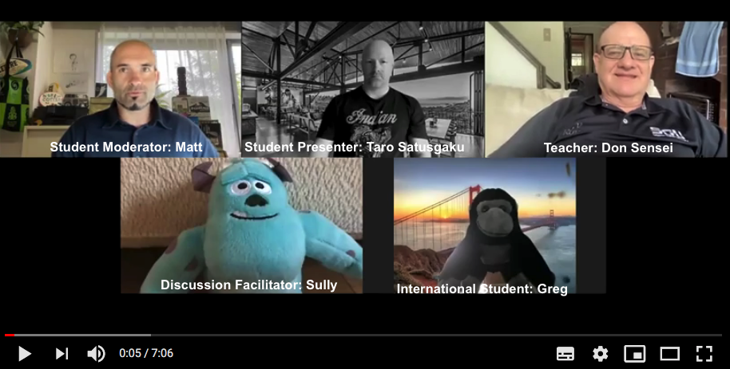

Participant Roles
- Student Moderator: MC, ask questions, keep conversation going
- Student Presenter: Present and answer questions about presentation
- Teacher: Tech Support and Facilitation
- Discussion Facilitator: Think of and ask good questions
- International Participants: Ask questions, engage in discussion, learn about Japan
- Everyone: Have fun!

Preparation
- Try to use a computer - iPads, tablets and mobile phones have less functions in Zoom
- Check your microphone is turned up (in your computer settings)
- Make sure your computer messenger apps have the sound off (and smartphone)

Before starting your presentation
- Relax and smile
- Share your screen: Ask teacher to “Please allow me to share my screen”
- Record your presentation: Ask teacher to “Please allow me to record”

During the presentation
- Show your smiling face. Look at the camera most of the time. Speak slowly and loudly. Stress key words.
- Point to key words and pictures on the PowerPoint with your cursor. Remember to use gestures.
- Make a fun atmosphere!
- If you make a mistake…. No problem! Just laugh and say “Sorry, one more time” …

After the presentation
- Stop recording after the Q&A. The recording file will save to your computer when the Zoom meeting ends.
- Follow your teacher’s instructions to upload into Moodle.

