SGU Student Conference Zoom July 12

ZOOM and Procedure Guide

Watch sample video: https://youtu.be/Qo_pfDFsHlw
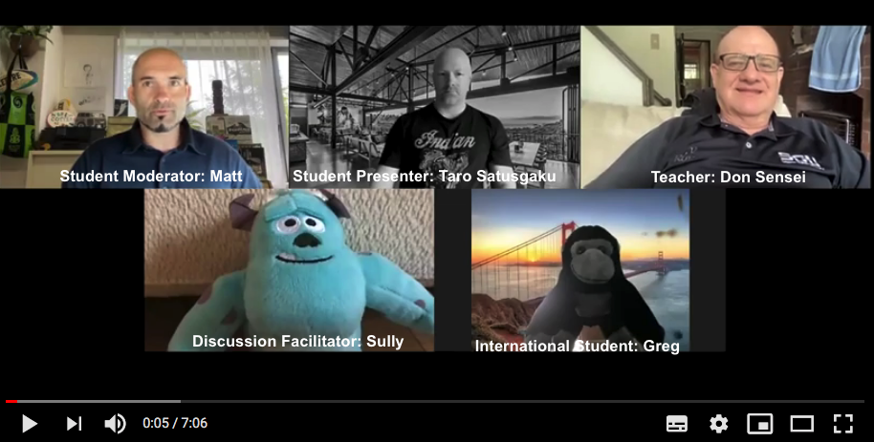

Participant Roles
- Student Moderator: MC, ask questions, keep conversation going
- Student Presenter: Present and answer questions about presentation
- Teacher: Tech Support and Facilitation
- Discussion Facilitator: Think of and ask good questions
- International Participants: Ask questions, engage in discussion, learn about Japan
- Everyone: Have fun!

Advice for Logging in
- Only one person is allowed to login using the ID and password provided.
- That person is called the “host”. The host should make the other two moderators as “co-hosts”
- If you have a “Basic” license, you cannot make co-hosts. You spotlight the speaker manually.

Advice to give to presenters when they enter
- Ask to change names to English if not already
- Ask if they are using a computer (ipads, tablets and phones show fewer functions in Zoom)
- Remind them they will record their own presentation at presentation time and stop after Q&A

Starting the conference
- Put screen into Gallery view.
- Do opening speech to welcome everyone
- Introduce yourself, other moderators, and teacher

Warm up

Option 1: Introductions as a Whole Group in Main Room (Recommended, it is easier)
- Put screen into Gallery view.
- Moderator calls on each person by name (be sure to get Zoom names in English in the welcome period)
- Moderator asks each person to introduce themselves. Questions can follow immediately after each person or after all have answered, or both.
- You can ask international guests why they are interested in Japan, and lead a discussion on that. Discussion facilitators, teachers, moderators should not hesitate to ask questions--calling others by name.

Option 2: Introductions in Breakout Rooms (Only try if confident)
- Only host and co-hosts can make breakout rooms
- Assign room members manually, starting with one international guest per room.
- Assign discussion facilitators to different rooms. Assign other members manually and randomly.
- If there is only one international guest, no need for breakout rooms, stay in Main Room.

Presentations

How to Share Screens
- Host clicks on the the small green triangle to allow multiple presenters
- Presenters get their powerpoint open on their computer
- Presenters click the square green button to Share Screen (画面の共用)

How to Allow Presenters to Make a Recording
- Teacher goes to the zoom participant small window, and clicks on three dots
- Teacher clicks on “Allow to record”. Moderator asks presenter to start the recording
- Teacher tells the presenter to stop recording after Q&A is over.
- Presenter clicks on the record button to end the recording.
- The recording file (zoom_0.mp4) is saved and downloaded onto the presenter’s computer after the meeting has ended.
- SGU account rooms are set to do an automatic whole session recording, not individual recordings.
- Teachers who require students to submit their recordings to Moodle should have a backup plan (ask a moderator to record whole session) in case a student forgets or can’t do it (i.e. make their own recording later by themselves)

